Sigma Phi Epsilon
Start Time: 6:00pm
Date: April 29, 2015
Location: Gemmell MPR

SIGEP CORNHOLE TOURNAMENT REGISTRATION FORM

WEDNESDAY, April 29, 2015 @ 6:00PM

TEAM NAME: ______________________________
PLAYER 1 NAME (CAPTAIN): __________________
PLAYER 2 NAME: __________________
CAPTAIN PHONE: ___________________ CAPTAIN EMAIL: _____________________
Make checks payable to: Sigma Phi Epsilon – PA Upsilon

SEND THIS FORM AND $10 REGISTRATION FEE TO:
Sigma Phi Epsilon – Clarion PA Upsilon
Gemmell Student Complex, Box #14
Clarion, PA 16214

*OR TURN THIS FORM AND $10 REGISTRATION FEE INTO THE GEMMELL INFO DESK*

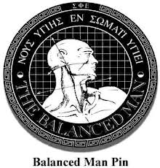
Bean Bag Toss Tournament

Registration Fee: $10 per team ($15 at the door)
Winning Team receives $100 CASH!

Questions?
Contact Scott Anderson
s.anderson2@eagle.clarion.edu

-------------------------------------------DETACH THE PORTION BELOW-------------------------------------------

